**Determining Author’s Purpose Name:_________________________**

**LT: I can define the three forms of author’s purpose.**

**LT: I can read a text with the goal of determining author’s purpose.**

**Directions:** Read the attached articles with the goal of determining which article is meant to persuade and which is meant to inform. Once you think you have identified which is informative and which is persuasive. Answer the following questions:

INFORMATIVE TEXT:_______________________________________________(Article Title)

1. Informative articles often provide background information on the topic before they dig into the main idea. Where does this article provide background information? What information is provided to us before we learn more?
2. What is the main idea the author is trying to inform us about in this article?
3. Provide three interesting facts/statistics below from the article that support your answer that this is informative:

Evidence #1-

Evidence #2-

Evidence #3-

PERSUASIVE TEXT:_________________________________________________(Article Title)

1. Persuasive texts ask the reader to do something, to change our minds, take action, or even simply consider a point of view. What is this article persuading its readers to do?
2. In order to be successful, persuasive texts must give us reasons for taking action or changing our opinions. What are two reasons are provided in this article to support their opinion?  
     
   Reason #1-  
     
     
   Reason #2-
3. Every time we provide a reason for an opinion, we should provide facts, examples, etc. to support that reason. What evidence is provided in this article that supports their reasons?

Evidence for Reason #1-

Evidence for Reason #2-

WHAT DO YOU THINK?

1. Both of these articles talk about selfies, from the reasons we take them to the affects they have on us. After reading these articles, what do you think about selfies? Are they important to who we are as a society today? Do they have negative or positive effects on our identities? Explain.

# **Selfies Cause Narcissism, Mental Illness, Addiction and Suicide?**

Added by [Rebecca Savastio](http://guardianlv.com/author/bsavastio/) on April 8, 2014.

Saved under [Health](http://guardianlv.com/category/health/), [Technology](http://guardianlv.com/category/technology/)

Tags: [selfies](http://guardianlv.com/tag/selfies/), [spot](http://guardianlv.com/tag/spot/)

image: http://guardianlv.com/wp-content/uploads/2014/04/selfie-650x325.jpg

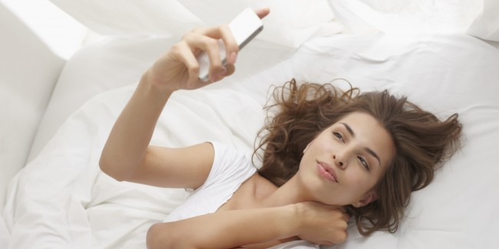

Is it possible that selfies, the trend of taking pictures of oneself, could cause narcissism, addiction, mental illness and even suicide? That’s what seems to be suggested by expert opinion surrounding the phenomenon, and a man diagnosed with body dysmorphic disorder says he grew suicidal due to his addiction to taking selfies. Danny Bowman says he became so obsessed with trying to take the “right” selfie that he ended up shooting about 200 pictures a day while trying desperately to capture the perfect image of himself.

When Bowman failed to take what he perceived to be the perfect selfie, he attempted suicide by taking an overdose of drugs. Prior to his suicide attempt, he says, he would spend about ten hours every day taking selfies. Dr. David Veal, a physician involved in caring for Bowman, says selfies may cause mental illness, including body dysmorphic disorder, which has “an extremely high suicide rate.”

Bowman’s parents are both mental health professionals, and they say that society has a “huge lack of understanding” about just how very dangerous electronic gadgets and social media can be to teens and adults alike. Experts say that while gadgets and social media cause addiction and other dangers, people are in extreme denial about the level of threat these types of communications pose, especially to impressionable teens.

Bowman’s parents recount how Bowman would spend many hours in his room taking selfies until his addiction culminated in not only a drastic weight loss, but also a terrifying suicide attempt. While Bowman’s case may sound unique and extreme, experts in psychology as well as medical doctors say this problem is far more widespread than is generally understood.

In an article for *Psychology Today*, doctor Pamela Rutledge says that taking selfies can be detrimental to a person’s mental health and that indulging in them is indicative of narcissism, low self esteem, attention seeking behavior and self-indulgence.

Most likely, the news that selfies might possibly cause a variety of troubling mental health issues is not going to be met with much acceptance by a society obsessed with the self-reflective nature of electronic gadgets. Some experts and physicians feel that society is collectively engaged in deep denial about how dangerous it is to interact with screens without setting limits on how much time is spent doing so.

Doctor Rutledge points out that while selfies raise the risk of narcissism, it may only be because there is not yet a widespread, well-established context for their use. She says that taking selfies may indeed be normal and natural, but because society has not yet collectively been able to contextualize the place selfies are supposed to hold, they have been labeled as being narcissistic and therefore can cause feelings of narcissism in those who take them.

However, it has been proven by multiple studies that interacting with other types of social media is definitively linked to narcissism, depression, low self esteem, addiction and a host of other negative effect. For example, Facebook use has been linked to depression while Twitter use has been linked to low self esteem and narcissism. If selfies, specifically, are proven in the future to cause these negative mental health issues, it would most likely come as no surprise to experts in the fields of psychology and medicine.

Is it possible that taking selfies causes mental illness, addiction, narcissism and suicide? Many psychologists say yes, and warn parents to pay close attention to what kids are doing online to avoid any future cases like what happened to Bowman. Thankfully, due to the diligence of his parents, he is alive today, but had his parents not gotten him help for his addiction to selfies, he may not have been as lucky.

By: Rebecca Savastio

Read more at <http://guardianlv.com/2014/04/selfies-cause-narcissism-mental-illness-addiction-and-suicide/#YFzvBDDWfwDklHFc.99>

**The Science of Selfies: How Pictures Help Us Claim Our Identiy**

This week's selfie at the Oscars was a [record-breaker for Twitter](http://www.today.com/entertainment/ellens-oscar-selfie-earns-3-million-charities-2D79317922), but just a drop in the bucket for the traffic in smartphone self-portraits.

A [survey commissioned by PicMonkey](http://www.marketwired.com/press-release/picmonkey-survey-finds-nearly-half-us-adults-have-taken-selfie-miley-cyrus-posts-most-1876623.htm) suggests that nearly half of all U.S. adults have taken selfies — making enough of a cultural impact that "selfie" was crowned as [Oxford Dictionaries' word of the year](http://www.today.com/news/oxford-dictionaries-names-selfie-word-year-2D11603600) for 2013.

We may be in the midst of a golden age for selfies, but the phenomenon raises its head every time a pictorial form rises up, whether we're talking about [mummy portraits](http://en.wikipedia.org/wiki/Fayum_mummy_portraits) from ancient Egypt, [marble busts](http://www.nbcnews.com/id/31527427) from the Roman Empire,[pictures from the dawn of photography](http://publicdomainreview.org/collections/robert-cornelius-self-portrait-the-first-ever-selfie-1839/) in the 19th century or an [eerily modern-looking group shot](http://collections.mcny.org/C.aspx?VP3=SearchResult_VPage&VBID=24UP1GVKB8UO&SMLS=1) from 1920.

MUSEUM OF THE CITY OF NEW YORK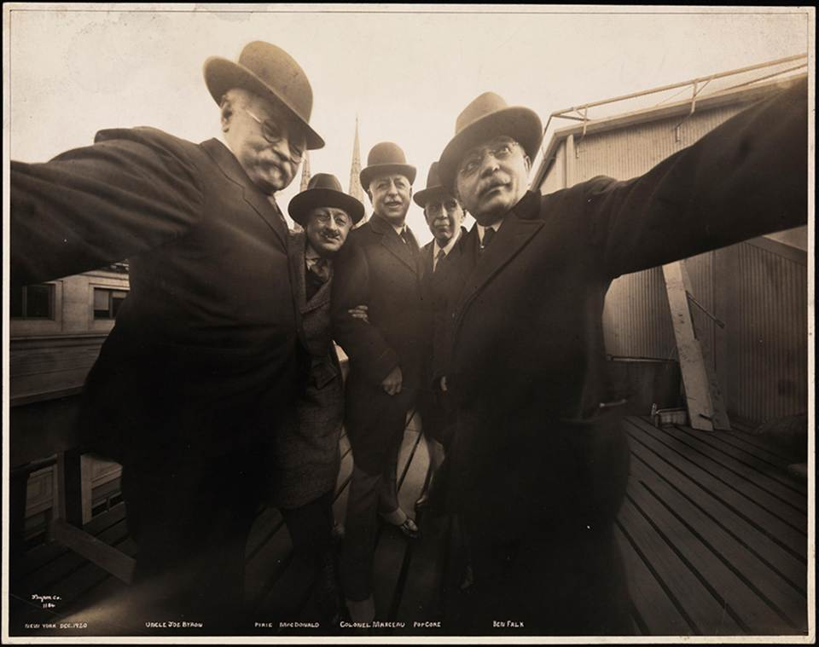

Five photographers pose together for a photograph on the roof of Marceau's Studio, while Joseph Byron holds one side of the camera with his right hand and Ben Falk holds the other side with his left hand, in 1920.

Is there a reason why selfies have resonated so deeply throughout history? They could well feed a psychological need to extend a claim of personal identity into new territory, in real life or cyberspace. That's according to Jennifer Ouellette, a science writer whose latest book is ["Me, Myself and Why: Searching for the Science of Self."](http://www.jenniferouellette-writes.com/memywhy.html)

"Your Facebook page, for instance, is one gigantic identity claim," Ouellette told NBC News. "It's how you wish to be perceived. If you want to get artsy-fartsy, you could say it's a form of performance. ... I think the selfie phenomenon is a different version of that. It is definitely a way of saying, 'Here I am. This is me.' It's a mirror kind of thing, particularly since people often turn the camera on themselves.'"

So many selfies are being taken that it's become possible to do statistical analysis, as an international project called[SelfieCity](http://selfiecity.net/) did for a study released last month. Researchers grabbed 656,000 photos from Instagram and winnowed them down to concentrate on 3,200 selfies from five cities. They found that women consistently posted more selfies than men did, and that Bangkok's selfies were significantly happier-looking than Moscow's.

**Avatars and totems**

Prolific selfie-makers may suffer from the same rap that applies to celebrities and reality-TV contestants — that they're narcissistic and focus too much on appearances. But such efforts to claim identity are, well, part of being human.

As Ouellette explains in "Me, Myself and Why," we all have a need to assert who we are, and understand who we are in the context of a wider world. That's why we create online avatars that may or may not reflect our real-life personality. (Ouellette admits that her avatar, [Jen-Luc Piquant](https://twitter.com/JenLucPiquant), is far more narcissistic than she is.)

COURTESY OF JENNIFER OUELLETTE

Science writer Jennifer Ouellette and her husband, Caltech physicist Sean M. Carroll, gaze into the camera for a selfie at left. At right, their Second Life avatars, Jen-Luc Piquant and Seamus Tomorrow, sit for a virtual selfie.

It's also why we surround ourselves with "totems" that serve as external connections to our internal lives — items that can range from posters on the walls and pictures on our desks to trophy cases and custom-made bobbleheads.

Such objects can play multiple roles: Ouellette points to the fob on her key chain as an example: It's decorated with the astrological symbol for Taurus, which has earned her a little grief from some scientists. Sure, Ouellette was born under the sign of Taurus — but she puts absolutely no stock in astrology. In this case, she keeps the key chain instead to remind her of a close friend and fellow Taurean who died of AIDS. It serves as what psychologists call a "feeling regulator" rather than an identity claim.

Here's another example: Which way are the pictures on your office desk facing? If they're facing toward you, they're feeling regulators. If they're facing toward your visitors, they're identity claims. Either way, they serve an important role in defining the self.

"Without external props, even our personal identity fades and goes out of focus," Ouellette quotes cultural historian Mihaly Csikszentmihalyi as saying. "The self is a fragile construction of the mind."

MUSEUM OF THE CITY OF NEW YORK

How was that 1920 selfie taken? Here's a side view of showing the photographers while they were snapping the picture.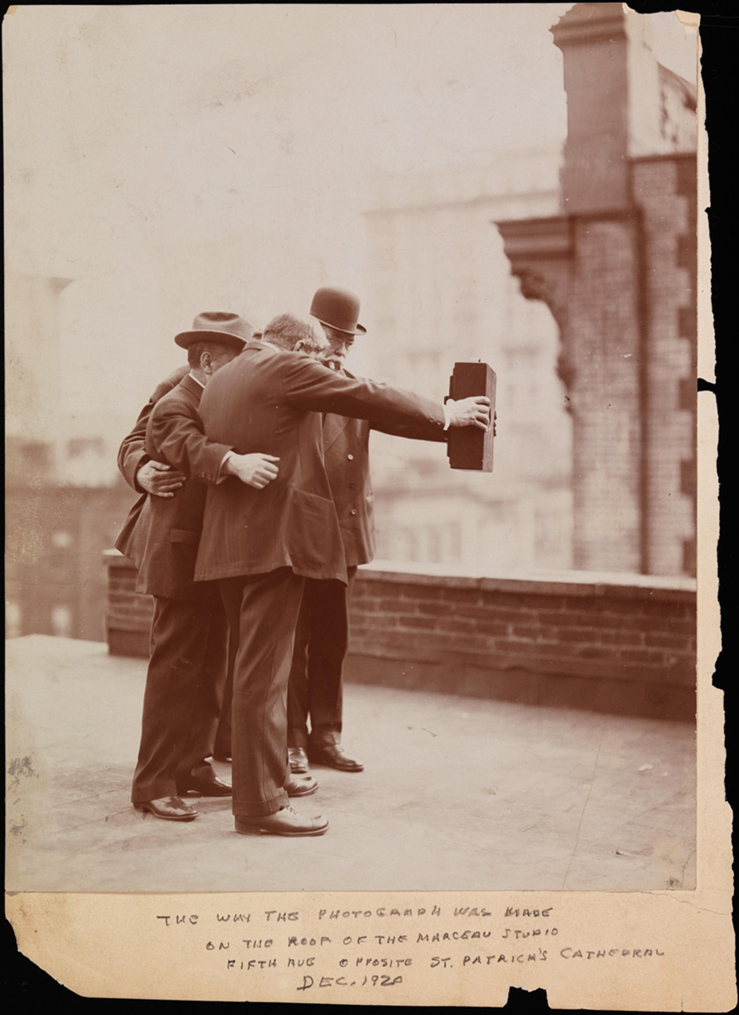

Ouellette delves into the entertaining experiments she went through to test the limits of the self. She took a battery of personality tests to find out where she landed on the [Myers-Briggs](http://www.myersbriggs.org/my-mbti-personality-type/mbti-basics/) and [Big Five scales](http://www.outofservice.com/bigfive/). (You can take a [free online test](http://www.16personalities.com/) to get an idea how it works ... bearing in mind that you may get what you pay for.) She had her [genome analyzed by 23andMe](https://www.23andme.com/) to fill in the gaps in her family history. She underwent an MRI scan to trace the geography of her brain. And she took a closely supervised LSD trip that almost literally blew her mind.

"I now totally get the art from the 1960s," she joked. "I liked the feeling of being disembodied, and having my eye floating and merging with all the other molecules. ... What it does is, it messes with your boundaries between self and the other."

**The future of the self**

Technology may well turn tomorrow's selfies into immersive, interactive virtual snapshots that persist long after you've passed away — kind of like the portraits of long-dead headmasters that hung on Hogwarts' walls in the Harry Potter novels.

"My great-grandchildren can come and talk to me," virtual-world researcher [Jacqueline Morie](http://alltheseworldsllc.com/company/) told Ouellette. "I may look like an eight-bit video game to them, but it will be charming, like looking at a black-and-white photo, except it will be interactive."

After all this self examination, what has Ouellette learned?

"I certainly have a much deeper, more nuanced notion of the self than I did before," she said. In her view, the self is not something that exists apart from the body, like the classical conception of the soul. But neither is it an illusion. Rather, it's a construct that emerges from experience.

"This notion of the self being rooted in mind and matter being intertwined makes perfect sense to me," she said. "But the brain does construct something that's far greater than the sum of the parts. It creates this amazing thing that can always be in flux, always changing and evolving and adapting to circumstances. ... I have tremendous respect for just how complex the self is."